**Adders:**

**Half Adder Equations:**

S =

Cout =

**Half Adder:**

|  |  |  |  |
| --- | --- | --- | --- |
| A | B | Cout | S |
| 0 | 0 |  |  |
| 0 | 1 |  |  |
| 1 | 0 |  |  |
| 1 | 1 |  |  |

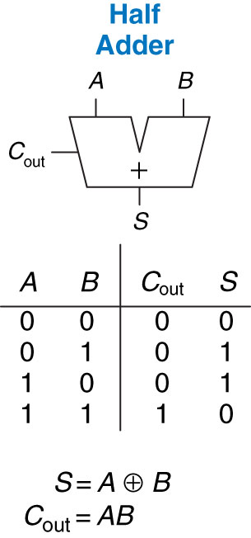

**Half Adder Schematic:**

**Half Adder Limitations?**

**Full Adder:**

|  |  |  |  |  |
| --- | --- | --- | --- | --- |
| Cin | A | B | Cout | S |
| 0 | 0 | 0 |  |  |
| 0 | 0 | 1 |  |  |
| 0 | 1 | 0 |  |  |
| 0 | 1 | 1 |  |  |
| 1 | 0 | 0 |  |  |
| 1 | 0 | 1 |  |  |
| 1 | 1 | 0 |  |  |
| 1 | 1 | 1 |  |  |

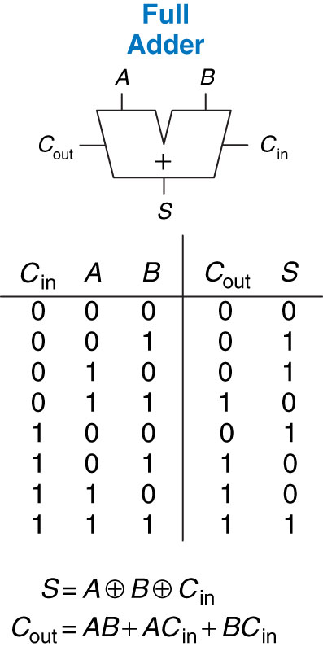

**Full Adder Equations:**

S =

Cout =

**Carry Propagate Adder:**

**Carry Propagate Types:**



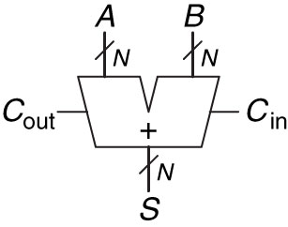

**Ripple Carry:**



🡺

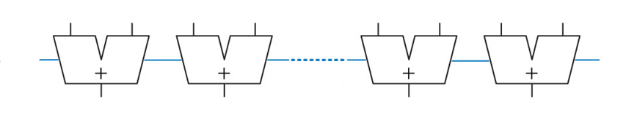

**Carry Lookahead:**



🡺

**Generate –**

**Propagate –**

**Examples:**

**?**

**?**

**🡨**

**?**

**?**

**?**

**🡨**

**?**

**?**

**?**

**Why?**

**Generate Propagate Schematic:**

**AND –**

**OR –**

**AND –**

**Prefix Adder:**



🡺

**Subtractors:**

How do we subtract?

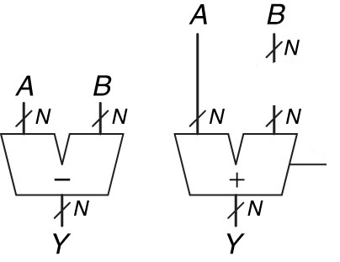

**Comparators:**

**Equality Comparators:**

|  |  |  |
| --- | --- | --- |
| **XNOR** | | |
| A | B | Y |
| 0 | 0 |  |
| 0 | 1 |  |
| 1 | 0 |  |
| 1 | 1 |  |

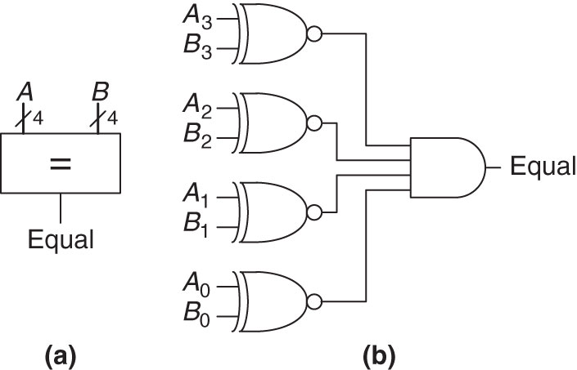

**Magnitude Comparators:**

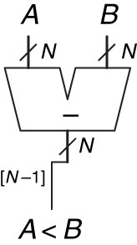

**Draw an N-Bit Comparator:**

**Why are Comparators useful?**

**Implement this function using things we learned today?**

**No Gates..Just Logic Functions**

**If a < 4**

**z = y + 3**

**else**

**z = y + 7**